PROTEIN SPARING MODIFIED FAST

How to speed up weight loss and break stalls.

INTRODUCTION
Contents

What is a Protein Sparing Modified Fast? 5
Thermic Effect of Food 5
PSMF Example 6
BREAK”FAST”
French Toast Porridge 8
Chicken Breakfast Patties 9

MAIN
DISHES
Broiled White Fish
with Tartar Sauce 11
Keto Fried Rice
with Ground Chicken 12

SNACKS
Keto (Venison) jerky 14

SWEET TREATS
Snow Cones 16

MEAL PLANS
Meal Plan Example 18
Day 1 18
Day 2 18

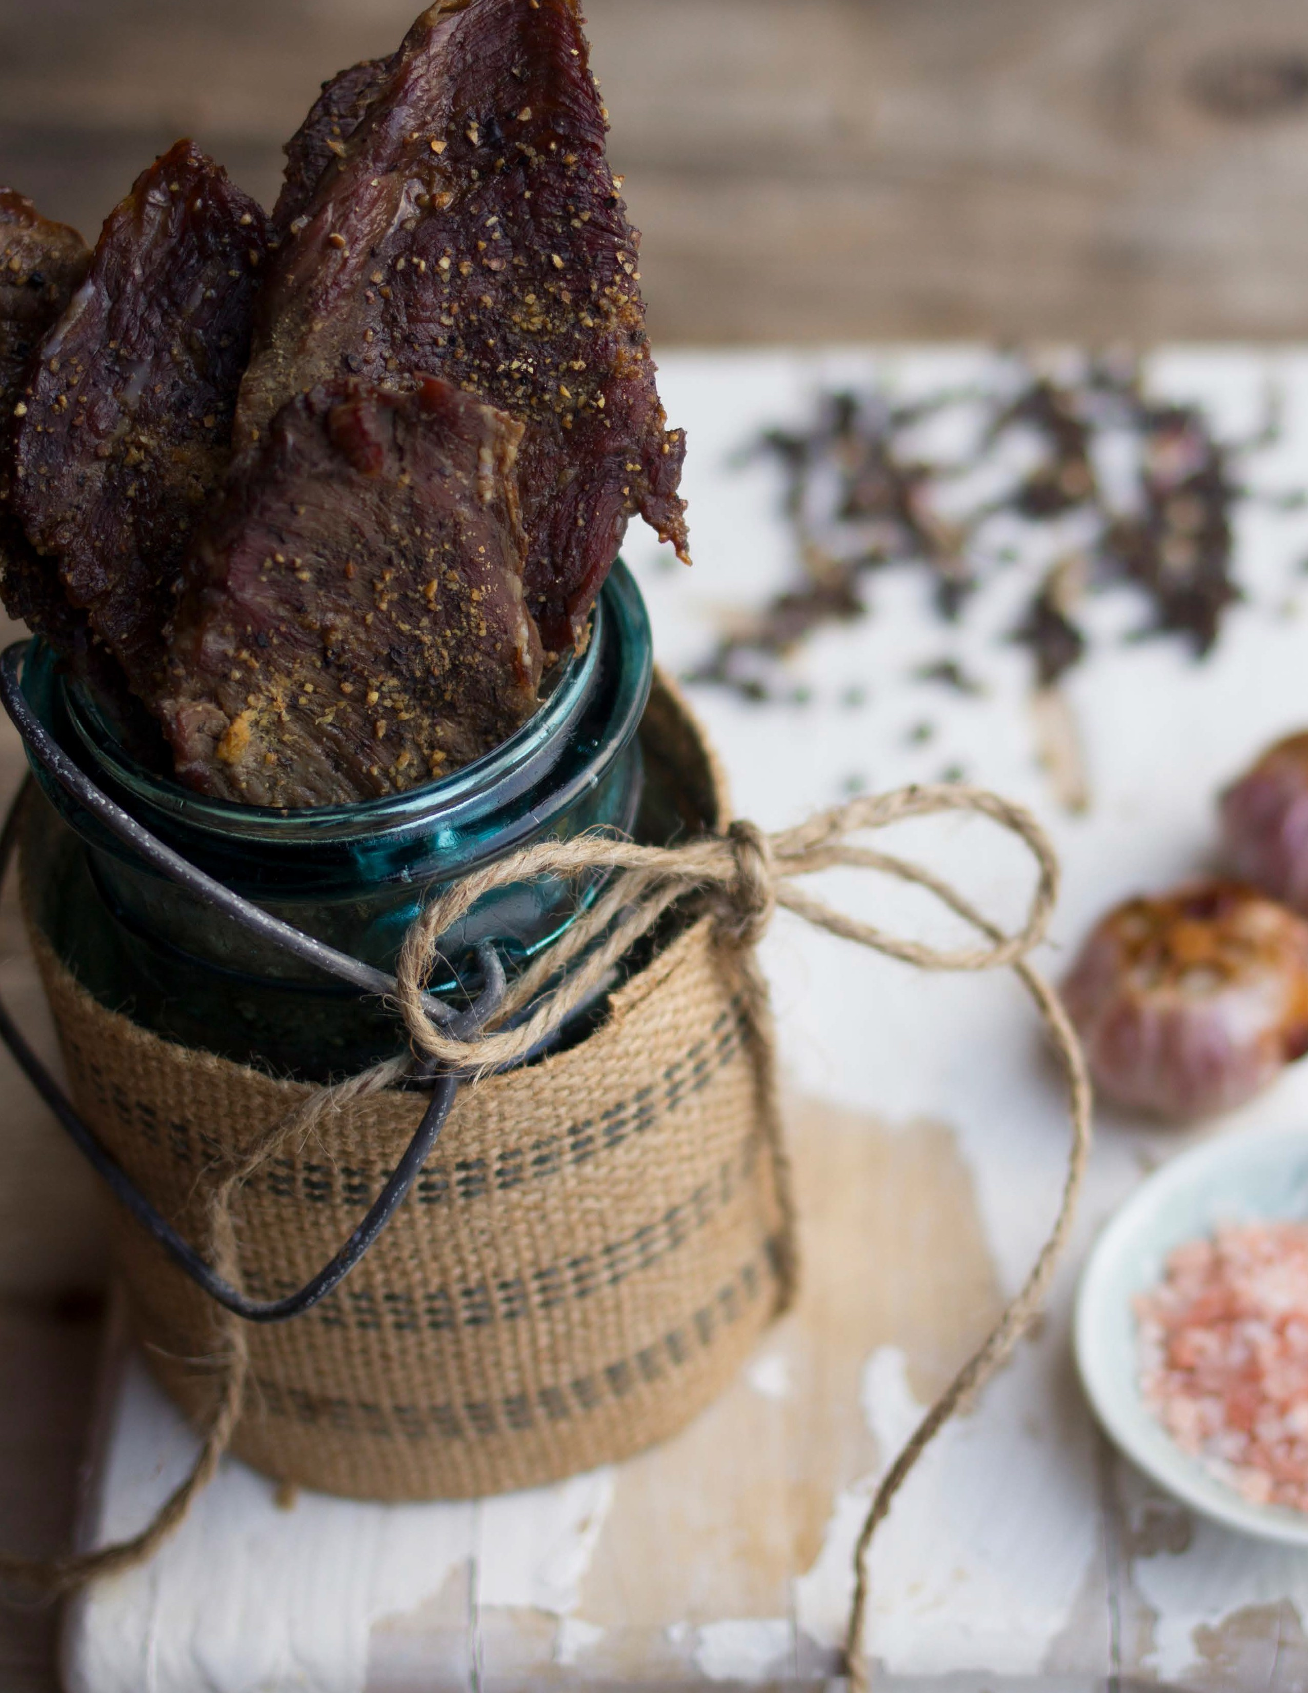Introduction

WHAT
IS
A
PROTEIN
SPARING
MODIFIED
FAST?
Protein Sparing Modified Fasting (PSMF) is a pattern of eating where you get many of the benefits of fasting (weight loss, improved insulin sensitivity, etc.), without the negatives (loss of lean mass). In a water fast you lose about a third of a pound of lean mass each day of the fast. A 3 day fast during a week results in the loss of a pound of lean mass. Lean mass is not easy to build and we don’t want to lose it if we can avoid it.
The idea behind a PSMF is to reduce carbs and fat as much as possible while still hitting your protein goal or even getting a bit more protein than your target. Instead of 0.8 times your lean mass for your protein goal, you want maybe 1.0 times your lean mass when doing a PSMF. The additional protein makes your body use even more stored fat for fuel, helps break stalls or accelerate weight loss and healing, and helps keep you feeling full, while also giving you the added benefit of the high thermic effect of food with protein, which means that you effectively lose 25 percent of the calories you take.
You also want to get some fat during this type of fast to ensure that you keep your hormones happy and that fat-soluble vitamins (A, D, E, and K) get absorbed. 30 to 50 grams of fat will be enough.
THERMIC
EFFECT
OF
FOOD
Thermic effect of food (TEF) is the amount of energy needed to consume and digest different macro nutrients. Some (protein) require much more energy to be consumed than others (carbs and fat). This means that the total calories consumed will result in different amount of effective calories in the body depending on what macro nutrients were consumed.
This chart shows you the thermic effect of different macro nutrients.

Macro Nutrient | Thermic Effect of Food | Calories Consumed | Effective Calories
Fat | 3% | 100 | 97
Carbohydrates | 8% | 100 | 92
Protein | 25% | 100 | 75

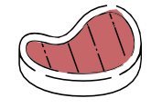Pure Protein Day

In my first book, Secrets to a Healthy Metabolism, I wrote about what I call a “pure protein day.” I knew there was a
strong thermic effect of food with protein. My guideline for a pure protein day was no carbs (no vegetables, either) and little fat.
I was afraid of the backlash from the keto community, so I started calling it a pure
protein and fat day. However, now that Craig and I understand the science behind protein-

sparing modified fasts, we know that the
pure protein day works, and we were right all along!
A pure protein day maintains muscle while you utilize the fat on your body to generate fuel and ketones. The thermic effect of the protein helps burn calories, too!
I often still eat my keto bread (I originally
called it “protein bread”) with scrambled eggs or a grassfed beef burger.

- Introduction

This chart shows how protein results in more TEF and less effective calories in the body. This is another of the reasons why PSMF are powerful tools for weight loss and forcing the body to consume more bodyfat for fuel which is fat loss.
EXAMPLE
PSMF
PSMF is something we treat a bit like water fasting in that we suggest you do it every once in a while—maybe a couple days a week or as needed to break a stall and increase weight loss.
Let’s look at an example. A woman that weighs 170 pounds and has 38 percent body fat means she has 105 pounds of lean mass.

170 x 0.38 = 64.6 pounds of bodyfat
170 - 64.6 = 105.4 pounds of lean mass
105 x 1.0 is 105 grams of protein
Her macros would be little to no carbs, 105 grams of protein, and about 40 grams of fat.

40 grams fat = 360 calories (1g fat is 9 calories) 360 minus TEF of 3% = 349 effective calories
105 grams protein = 420 calories (1g protein is 4 calories) 420 minus TEF of 25% = 315 effective calories
As you can see, this is like fasting while preserving lean mass because she is only getting about
780 calories, though only about 664 (349+315) of those calories are useful because of the thermic effect of food. She will get enough protein to preserve important lean body mass, but she will have to use a lot of stored fat to fuel her body. This is what makes PSMF such a great tool for accelerating weight loss or breaking a stall.
Being keto adapted before doing PSMF will be very helpful. It is not required but
it will make it much easier to do. When you are fully keto adapted (after 4-6 weeks or so) your body will be very efficient at tapping stored bodyfat for fuel. Most of our clients find that PSMF come very easy. The protein is very satiating and they actual stay full throughout the day.
“

Eight to ten years ago, Maria called this practice a “pure protein day.” Back then, we hadn’t heard of PSMF. We just knew the properties of the thermic effect of food and how our metabolisms worked, so we knew this could be helpful for people to lose weight faster. PSMF is becoming more popular and well-known and is a great tool for improving results.
So give it a try! You will love the results you see.

I tried a PSMF (“pure protein day”) today... I had to force myself to
hit that protein goal, I just wasn’t hungry. I used the recommendation from Maria’s calculator, and am going to try another one tomorrow... It doesn’t feel at all like “fasting”!

–Jillian

- Introduction

Break”Fast”

French Toast Porridge

Prep Time: 5 minutes Cook Time: 5 minutes Servings: 1

8 large egg whites
2/3 cup unsweetened almond milk
a few drops of stevia glycerite to taste 4 teaspoon maple extract
1/2 teaspoon fine sea salt
1 teaspoon butter-flavored coconut oil Sprinkle of ground cinnamon

7 - Break”Fast”
Nutritional Info (per serving)
Calories 195 | Fat 7g | Protein 29g | Carbs 2g | Fiber 0.4g

  - In a small bowl, whisk together the egg whites, almond milk, sweetener, extract, and salt.
  - In a medium-sized saucepan, melt the oil over medium heat. Add the egg mixture and cook, scraping the bottom with a wooden spoon, until the mixture thickens and starts curdling, about 4 minutes. Use a whisk to help separate the curds.
  - Once the curds form and the mixture has thickened, remove from the heat and transfer to a serving bowl. Sprinkle with cin- namon and serve with ¼ cup unsweetened almond milk if de- sired.

Chicken Breakfast Patties

Prep Time: 10 minutes Cook Time: 10 minutes Servings: 12 (24 total, 2 per)

3 pounds ground chicken or ground turkey 3 teaspoons finely chopped dried sage
2 teaspoons finely chopped dried thyme 1 teaspoon red pepper flakes
½ teaspoon ground nutmeg 1 teaspoon maple extract
¼ teaspoon stevia glycerite 1½ teaspoons fine sea salt
½ teaspoon fresh ground black pepper
1 teaspoon lard or coconut oil, for frying

8 - Break”Fast”
Nutritional Info (per serving)
Calories 289 | Fat 16g | Protein 31g | Carbs 3g | Fiber 1g

- Place all the ingredients and in a large bowl and mix together with your hands until the seasonings are distributed through- out the meat. To check the seasoning, fry up a small dab of the mixture in a skillet over medium heat; taste it and add more seasoning if desired.
- Form the sausage mixture into twenty-four 2-inch patties.
- Refrigerate the sausages for a few hours to allow the flavors to meld.
- Cook within 3 days. Can be frozen for up to a month for easy breakfasts!

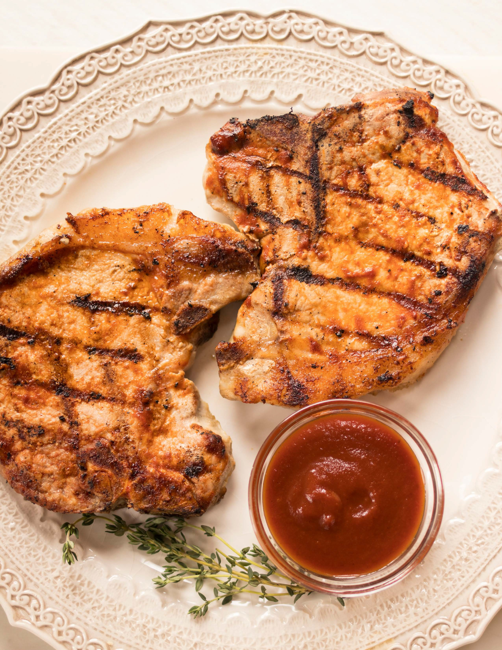Main
Dishes

Broiled White Fish with Tartar Sauce

Prep Time: 5 minutes Cook Time: 10 minutes Servings: 1

2 (6 ounce) fillets cod (or other white fish)
½ teaspoon fine grain sea salt
½ teaspoon smoked paprika
½ teaspoon garlic powder
½ teaspoon fresh ground pepper
½ tablespoons tartar sauce (page 51)
- Preheat broiler.
- Place cod on a cookie sheet with edges. Season fish with salt, paprika, garlic and pepper.
- Place into oven and broil for 10 minutes or until fish flakes easily with a fork and is cooked through. Serve with a sprinkle of lemon juice if desired.
- Store in an airtight container in the refrigerator for up to 3 days. To reheat, place on a rimmed baking sheet in a preheated 375°F oven for 5 minutes or until warmed through.
- Serve with tartar sauce.

Nutritional Info (per serving)
Calories 285 | Fat 10g | Protein 43g | Carbs 3g | Fiber 1g

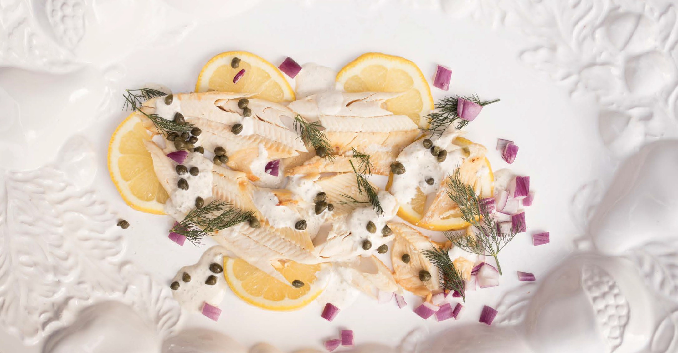

10 - Main

Keto Fried Rice with Ground Chicken

Prep Time: 5 minutes Cook Time: 15 minutes Servings: 4

12 large egg whites
½ cup beef bone broth, homemade or store-bought
2 teaspoons wheat-free tamari, or 3 teaspoons coconut aminos
1 teaspoon fine sea salt
½ teaspoon ground black pepper 1 teaspoon lard or coconut oil
¼ cup diced onions
1 clove garlic, minced
1 pound lean ground turkey or ground chicken
For Garnish (optional):
1 teaspoon crushed red pepper Thinly sliced scallions

11 - Main
Nutritional Info (per serving)
Calories 514 | Fat 31g | Protein 50g | Carbs 3g | Fiber 0.2g

- Place egg whites medium-sized bowl. Add the broth, tamari, salt, and pepper and whisk until well combined.
- In a large skillet over medium heat, place a teaspoon of lard or coconut oil. Add the onions and garlic to the skillet and sau- té until the onions are translucent, about 2 minutes. Place the ground turkey to the skillet. Cook for 2 minutes and season well with salt and pepper.
- Pour the egg mixture into the skillet and cook until the mixture thickens and small curds form, while scraping the bottom of the pan and whisking to keep large curds from forming. (A whisk works well for this task.) This will take about 7 minutes.
- Place the “fried rice” on a platter. Garnish with crushed red pepper and scallions, if desired, and serve.
- Store in an airtight container in the refrigerator for up to 3 days. To reheat, place the shrimp fried “rice” in a lightly greased sauté pan over medium heat, stirring often, for 2 minutes or until warmed through.

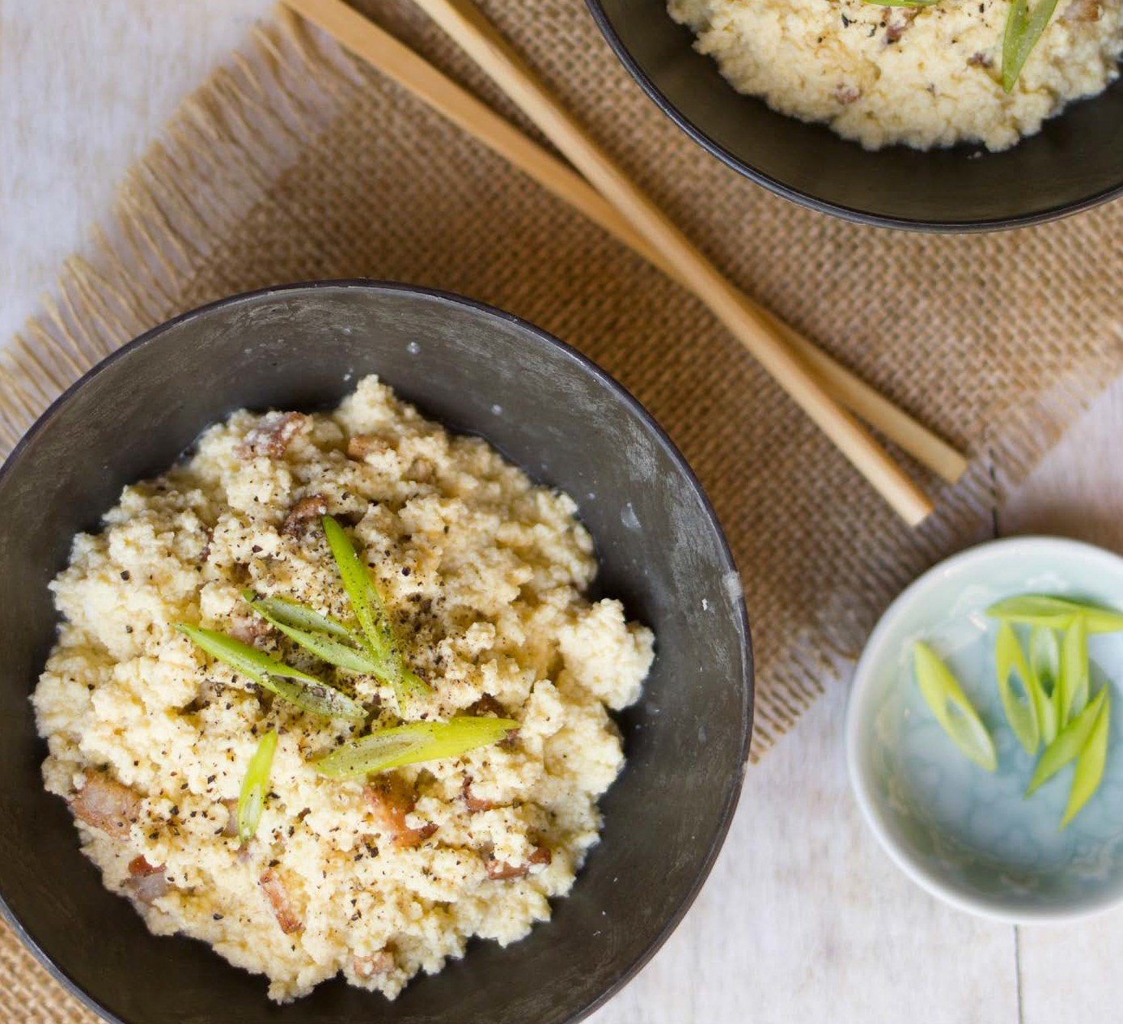

• I ·, • • ..

'· ...,
•.
"I

.....
I "'- )

. !iI
' •·
...

----=--

Prep Time: 5 minutes Cook Time: 6-8 hours Servings: 8
Keto (Venison) jerky
  - Place the meat in the freezer for 1 hour to make it easier to slice cleanly. Slice the meat across the grain into long strips, 1 inch wide and ⅛ inch thick.
  - Combine the marinade ingredients in a large shallow bowl. Sub- merge the strips of meat in the marinade, cover, and marinate in the fridge for at least 2 hours or overnight. Remove the meat from the marinade and sprinkle with the salt.

1 pound boneless venison or beef loin MARINADE:
½ cup organic wheat-free tamari
1 tablespoon MCT oil or macadamia nut oil
¼ teaspoon liquid stevia 2 tablespoons lime juice
1 tablespoon grated fresh ginger 1 teaspoon minced garlic
1 teaspoon fine sea salt
- Dehydrator method: Place the strips of meat in a dehydrator, not touching each other, and set the dehydrator to low (170°F).
- Oven method: If you do not have a dehydrator, preheat the oven to 160°F. Place a rimmed baking sheet on the bottom of the oven (or bottom rack) to catch drips. Arrange the strips of marinat- ed meat directly on the middle rack, not touching each other. Alternatively, place a wire rack on a rimmed baking sheet and arrange the strips of meat on the wire rack.
- For both methods: Dehydrate the meat for 6 to 8 hours, until the jerky dries to the desired chewiness. For a chewier jerky, dehydrate for less time.
- Store in an airtight container in the refrigerator for up to 2 weeks or in the freezer for up to a month.

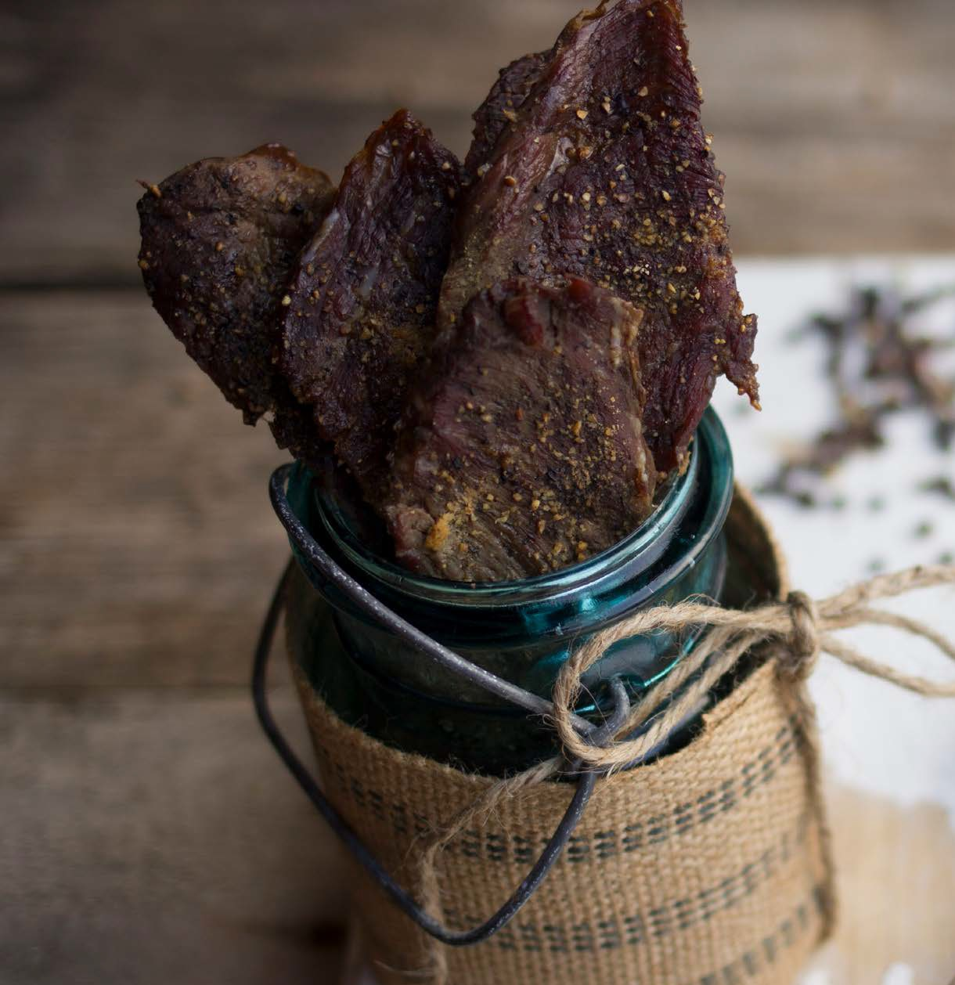

13 - Snacks

Jerky tastes great and is the ultimate por- table food. We often pack it on camping trips. But it is hard to find store-bought jerky that doesn’t contain gluten or soy. Thankfully, making homemade jerky is extremely easy; it just takes time to dehy- drate. My tip for you is to make a double batch and store it in the freezer.

Nutritional Info (per serving)
Calories 114 | Fat 3g | Protein 19g | Carbs 2g | Fiber 0g

Swee t Treats

Snow Cones

Prep Time: 2 minutes Cook Time: 0 minutes Servings: 1

1 cup shaved ice
1 tablespoon Everly mix (any flavor) 2 tablespoons water
1 Shave ice and place into a cup. Mix the Everly into the water. Drizzle over ice and enjoy!

Nutritional Info (per serving)
Calories 0 | Fat 0g | Protein 0g | Carbs 0g | Fiber 0g

15 - Sweet Treats

Test

Meal Plans

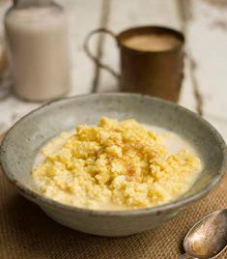
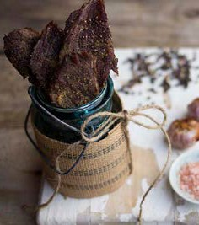
Meal Plan Example

Day 1 |  |  |  |  | Day 2
Begin Eating Window |  |  |  |  | Begin Eating Window
French Toast  Porridge  Servings:  Nutritional Info (per serving) |  |  |  |  | Chicken Breakfast Patties  Servings:  Nutritional Info (per serving)
calories  195 | fat  7g | protein  29g | carbs  2g | fiber  0.4g | calories  289 | fat  16g | protein  31g | carbs  3g | fiber  1g
Snack/Side or Dessert |  |  |  |  | Snack/Side or Dessert
Snow Cones  Servings:  Nutritional Info (per serving) |  |  |  |  | Keto Venison Jerky  Servings:  Nutritional Info (per serving)
calories  0 | fat  0g | protein  0g | carbs  0g | fiber  0g | calories  114 | fat  3g | protein  19g | carbs  2g | fiber  0g
End Eating Window |  |  |  |  | End Eating Window
Salt Crusted Fish  Servings:  Nutritional Info (per serving) |  |  |  |  | Keto Fried Rice with Ground Pork  Servings:  Nutritional Info (per serving)
calories  494 | fat  19g | protein  75g | carbs  2g | fiber  1g | calories  514 | fat  31g | protein  50g | carbs  3g | fiber  0.2g
Day 1 Totals |  |  |  |  | Day 4 Totals
calories  689 | fat  26g | protein  104g | carbs  4g | fiber  1.4g | calories  917 | fat  50g | protein  100g | carbs  8g | fiber  1.2g

17 - Meal Plans

